deleting alternative

#include<stdio.h>

#include<stdlib.h>

struct node

{

int data;

struct node \*next;

};

typedef struct node NODE;

struct llist

{

NODE \*head;

};

typedef struct llist LL;

void init(LL\*);

void insert(LL\*);

void rem(LL\*);

void display(LL\*);

int main()

{

LL q;

init(&q);

insert(&q);

printf("List before deleting\n");

display(&q);

rem(&q);

printf("List after deleting\n");

display(&q);

}

void init(LL \*q)

{

q->head=NULL;

}

void insert(LL \*q)

{

NODE \*temp;

int wish=1;

do

{

temp=(NODE \*)malloc(sizeof(NODE));

printf("Enter data\n");

scanf("%d",&(temp->data));

temp->next=q->head;

q->head=temp;

printf("Do you want to enter more values\n");

printf("Enter 1 for YES 0 for No\n");

scanf("%d",&wish);

}

while(wish);

}

void rem(LL \*q)

{

int i=0;

NODE \*p=q->head;

while(p!=NULL)

{

i++;

p=p->next;

}

p=q->head;

//printf("i value %d",i);

NODE \*f=p;

NODE \*prev=p->next;

p=p->next->next;

NODE \*t=prev;

printf("Deleted %d\n",f->data);

free(f);

if(p==NULL || p->next==NULL)

{

printf("Can't delete not sufficient data present\n");

exit(1);

}

int count=0;

while(p!=NULL)

{

if(count%2==0)

{

//printf("Hello");

f=p;

prev->next=p->next;

prev=prev->next;

}

//printf("%d\n",p->data);

p=p->next;

if(count%2==0)

{

printf("Deleted %d\n",f->data);

free(f);

}

if(i%2==0 && prev->next==NULL)

{

break;

}

if(i%2!=0 && count==i-2)

prev->next=NULL;

count++;

}

q->head=t;

}

void display(LL \*q)

{

NODE \*p=q->head;

if(p==NULL)

{

printf("Empty list\n");

}

while(p!=NULL)

{

printf("%d ",p->data);

p=p->next;

}

printf("\n");

}

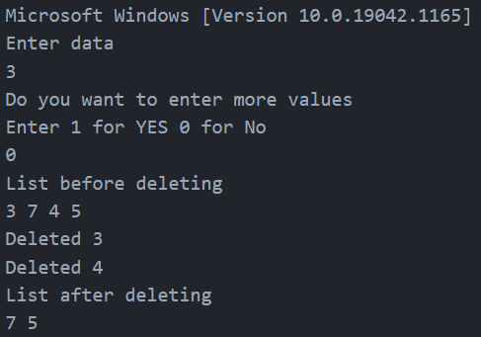

swapping

#include<stdio.h>

#include<stdlib.h>

struct node

{

int data;

struct node \*next;

};

typedef struct node NODE;

struct llist

{

NODE \*head;

};

typedef struct llist LL;

void init(LL\*);

void insert(LL\*);

void swap(LL\*,int,int);

void display(LL\*);

int main()

{

LL q;

init(&q);

insert(&q);

printf("List before swaping\n");

display(&q);

int a,b;

printf("Enter the data values you want to be swapped\n");

scanf("%d %d",&a,&b);

swap(&q,a,b);

printf("List after swapping\n");

display(&q);

}

void init(LL \*q)

{

q->head=NULL;

}

void insert(LL \*q)

{

NODE \*temp;

int wish=1;

do

{

temp=(NODE \*)malloc(sizeof(NODE));

printf("Enter data\n");

scanf("%d",&(temp->data));

temp->next=q->head;

q->head=temp;

printf("Do you want to enter more values\n");

printf("Enter 1 for YES 0 for No\n");

scanf("%d",&wish);

}

while(wish);

}

void swap(LL \*q,int a,int b)

{

NODE \*prev1=NULL;

NODE \*prev2=NULL;

NODE \*prev=NULL;

NODE \*p=q->head;

NODE \*t;

NODE \*pres1;

NODE \*pres2;

while(p!=NULL)

{

if(p->data==a)

prev1=prev;

if(p->data==b)

prev2=prev;

prev=p;

p=p->next;

}

if(prev1==NULL && q->head->data==a)

{

prev1=q->head;

pres1=prev1->next;

pres2=prev2->next;

t=pres2->next;

q->head=pres2;

pres2->next=pres1;

prev2->next=prev1;

prev1->next=t;

}

else if(prev2==NULL && q->head->data==b)

{

prev2=q->head;

pres2=prev2->next;

pres1=prev1->next;

t=pres1->next;

q->head=pres1;

pres1->next=pres2;

prev1->next=prev2;

prev2->next=t;

}

else if(prev2!=NULL && prev1!=NULL)

{

pres1=prev1->next;

pres2=prev2->next;

t=pres2->next;

prev1->next=pres2;

pres2->next=pres1->next;

prev2->next=pres1;

pres1->next=t;

}

else

{

printf("Entered value doesnt exist ");

exit(0);

}

}

void display(LL \*q)

{

NODE \*p=q->head;

if(p==NULL)

{

printf("Empty list\n");

}

while(p!=NULL)

{

printf("%d ",p->data);

p=p->next;

}

printf("\n");

}

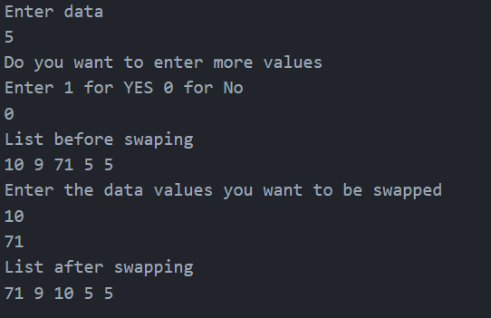

polynomial

#include<stdio.h>

#include<stdlib.h>

struct poly

{

int coeff;

int px;

int py;

struct poly \*next;

};

typedef struct poly POLY;

struct list

{

POLY \*head;

};

typedef struct list LL;

void init(LL\*);

void accept(LL\*);

POLY\* res(LL\*,LL\*,LL\*);

void display(LL\*);

int main()

{

LL q1,q2,q;

init(&q1);

init(&q2);

init(&q);

printf("Enter the first polynomial:\n");

accept(&q1);

printf("---------------------------\n");

printf("Enter the second polynomial:\n");

accept(&q2);

q.head=res(&q1,&q2,&q);

display(&q);

return 0;

}

void init(LL \*q)

{

q->head=NULL;

}

void accept(LL \*q)

{

POLY \*temp;

char c;

do

{

temp=(POLY \*)malloc(sizeof(POLY));

printf("Enter the coefficient:\n");

scanf("%d",&(temp->coeff));

printf("Enter the power of x:\n");

scanf("%d",&(temp->px));

printf("Enter the power of y:\n");

scanf("%d",&(temp->py));

temp->next=q->head;

q->head=temp;

fflush(stdin);

printf("Do you want to enter more values\n");

printf("Enter Y for yes N for No:\n");

c=getchar();

fflush(stdin);

}

while(c=='Y');

}

POLY\* res(LL \*q1,LL \*q2,LL \*q)

{

POLY \*p1=q1->head;

POLY \*p2=q2->head;

POLY \*p3=q->head;

POLY \*t=(POLY \*)malloc(sizeof(POLY));

while(p1!=NULL && p2!=NULL)

{

if((p1->px == p2->px) && (p1->py == p2->py))

{

t->coeff=(p1->coeff)+(p2->coeff);

t->px=p1->px;

t->py=p1->py;

t->next=p3;

p3=t;

p1=p1->next;

p2=p2->next;

}

else if((p1->px + p1->py)<=(p2->px + p2->py))

{

t->coeff=(p1->coeff);

t->px=p1->px;

t->py=p1->py;

t->next=p3;

p3=t;

p1=p1->next;

}

else if((p1->px + p1->py)>(p2->px + p2->py))

{

t->coeff=(p2->coeff);

t->px=p2->px;

t->py=p2->py;

t->next=p3;

p3=t;

p2=p2->next;

}

t=(POLY \*)malloc(sizeof(POLY));

}

while(p1!=NULL)

{

t->coeff=(p1->coeff);

t->px=p1->px;

t->py=p1->py;

t->next=p3;

p3=t;

p1=p1->next;

t=(POLY \*)malloc(sizeof(POLY));

}

while(p2!=NULL)

{

t->coeff=(p2->coeff);

t->px=p2->px;

t->py=p2->py;

t->next=p3;

p3=t;

p2=p2->next;

t=(POLY \*)malloc(sizeof(POLY));

}

return p3;

}

void display(LL \*q)

{

POLY \*p=q->head;

while(p!=NULL)

{

if(p->next==NULL)

printf("%dx(%d)y(%d)",p->coeff,p->px,p->py);

else

printf("%dx(%d)y(%d) +",p->coeff,p->px,p->py);

p=p->next;

}

}

